Table 1: Hypospadias Objective Penile Evaluation (HOPE Score) in studied groups.
 |  |  |  | e-TIP group  n = 46 | s-TIP group  (n = 48) | P value
Meatus |  |  |  | 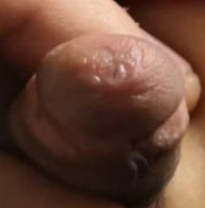 | 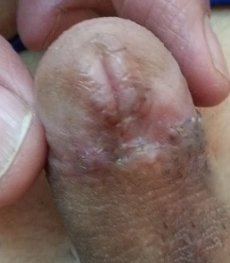
Meatus | Position of meatus | Position 1, n (%) |  | 38 (82.6) | 11 (22.9) | <0.001*
Meatus |  | Position 2, n (%) |  | 8 (17.4) | 37 (77.1)
Meatus | Position of meatus Score | Mean (SD) |  | 9.4 (1.3) | 8.3 (1.1) | <0.001**
Meatus | Shape of Meatus | Normal, n (%) |  | 38 (82.6) | 25 (52.1) | 0.002*
Meatus |  | Slightly abnormal, n (%) |  | 8 (17.4) | 23 (47.9)
Meatus | Shape of Meatus Score | Mean (SD) |  | 9.5 (1.2) | 8.5 (1.6) | 0.001**
Glans penis |  |  |  | 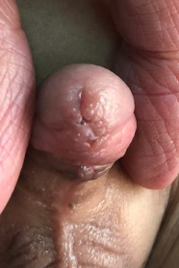 | 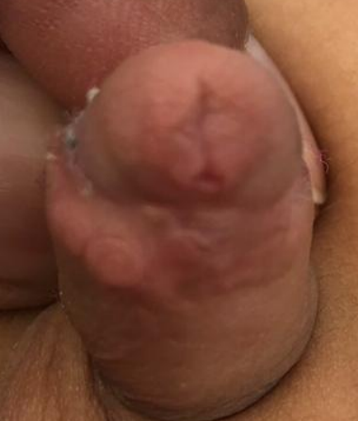
Glans penis | Shape of Glans | Normal, n (%) |  | 33 (71.7) | 31 (64.6) | 0.511*
Glans penis |  | Slightly abnormal, n (%) |  | 13 (28.3) | 17 (53.4)
Glans penis | Shape of Glans Score | Mean (SD) |  | 9.2 (1.3) | 8.9 (1.4) | 0.287**
Shape of Skin |  |  |  | 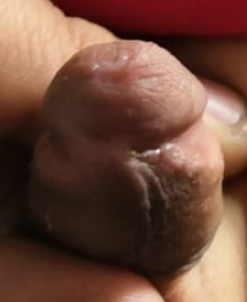 | 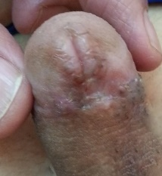
Shape of Skin | Shape of Skin | Normal, n (%) |  | 26 (56.5) | 23 (47.9) | 0.418*
Shape of Skin |  | Slightly abnormal, n (%) |  | 20 (43.5) | 25 (52.1)
Shape of Skin | Shape of Skin Score | Mean (SD) |  | 8.7 (1.5) | 8.4 (1.5) | 0.368**
Torsion | Torsion | Mild torsion, n (%) |  | 0 (0.0) | 0 (0) | –
Torsion |  | No, n (%) |  | 46 (100) | 48 (100)
Torsion | Torsion Score | Mean (SD) |  | 10 (0) | 10 (0) | –
Curvature | Curvature | No, n (%) |  | 46 (100.0) | 48 (100.0)
Curvature | Curvature Score | Mean (SD) |  | 10 (0) | 10 (0) | –
Total score |  |  | Mean (SD) | 56.9 (3.6) | 54.2 (3.4) | <0.001**
 |  |  | Median (IQR) | 57 (45–60) | 55 (44–60) | <0.001**
*Fisher’s Exact test. **Mann-Whitney U.

